Dear Applicant, Tuesday, 05 January 2021
Re: YMCA WiSE Project Worker – Brighton & Hove
Closing date: Wednesday 20th January 2021 at 9am
Interview date: TBC

Thank you for your interest in joining the YMCA DownsLink Group.
This job pack contains the following:
- Job Profile and Person Specification – to refer to on your application
- Principal Terms & Conditions
- Welcome to Applicants
- The YMCA Movement, Our Vision, About Us and Our Structure
- Policy on the Recruitment of Ex-Offenders

To apply, use this job pack and person specification to complete the application form and submit via email to recruitment@ymcadlg.org, preferably as a Word document. Put the job title in the subject bar and ideally save your application as ‘your name APPLICATION’. If you would like a form with a dyslexia-friendly font, please get in touch.
If you have not heard from us within 2 weeks of the closing date, please assume that your application was not successful on this occasion.
YMCA DownsLink Group welcomes applications from all sections of the community. We value diversity and promote inclusion, which we demonstrate through our activities, as well as in our policies and working practices. Reinforced by our culture and values, we seek to create an inspiring and inclusive place to work.

YMCA DownsLink Group requires all staff and volunteers to be committed to safeguarding and promoting the welfare of children, young people and vulnerable adults. Successful applicants are required to undertake a full enhanced disclosure via the Disclosure and Barring Service (DBS).

We look forward to receiving your application.
Yours faithfully,
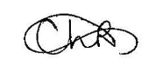
Charley Lockie
Recruitment and HR Administration Manager

Job Profile WiSE Project Worker
Reporting to WiSE Project Manager
Service Area Children & Young People’s Services

WiSE is a specialist sexual exploitation service, delivered by YMCA DownsLink Group and operating across East Sussex, Brighton & Hove and Surrey.

Job Purpose
To provide case work support or peer group interventions to young people (up to 25 years) who have been identified as being at risk of / or experiencing sexual or criminal exploitation.
To work collaboratively with other professionals and support interventions that lead to prosecutions and measures to disrupt the activity of perpetrators.
To provide consultation, support and guidance to other professionals working directly with children and young people who are at risk of, or being exploited.

Responsibilities
- To carry a caseload of young people who have been identified as vulnerable to / experiencing sexual or criminal exploitation and support them to stay safe and work towards leaving the influence of perpetrator/s.
- To work closely with other professionals to provide an intensive care package which is specific to the needs of the individual young person, and provide consultation support / guidance to other professionals.
- To keep detailed case notes and monitoring information and contribute to the timely production of reports as required.
- Participate in safeguarding meetings such as strategy meeting and case conferences, and Missing and Exploited Children’s Conferences.
- To work closely with Children’s Services and Sussex Police around intelligence and information-sharing in order to support the disruption of abuse and prosecutions, including providing evidence in court proceedings.
- Where appropriate to liaise with parents / carers linking them to appropriate support services, and provide them with a point of contact in relation to the co-ordination of support around their child.
- To work with other WiSE staff and other professionals to facilitate interventions with peer groups in young people’s settings such as schools, supported accommodation and youth groups. This includes working closely with the WiSE Participation & Engagement Worker to support the safe and appropriate involvement of WiSE casework clients in participation opportunities.
- Occasionally, as part of the wider team deliver training and awareness-raising workshops to professionals, foster carers and others around CSE and wider forms of Child Criminal Exploitation
- Occasionally, as part of the wider team help create and deliver awareness raising campaigns targeting a range of audiences.
- To keep informed of relevant policy changes, serious case reviews and research relating to sexual exploitation.
- To maintain confidentiality of YMCA DownsLink Group and other partner agencies.
- To attend and participate fully in YMCA DownsLink Group staff team meetings, staff training programme and supervisions.
- To work with the WiSE Project Manager and Head of YIACS and Targeted Services to input into strategic / operational development locally relating to exploitation, and deputise in the attendance at relevant meetings when required.
- To carry out from time to time any other appropriate duties as directed by line manager to support and promote the work of the charity.
- To work within all YMCA DLG policies and procedures at all times and to abide by the Code of Conduct.
- To attend YMCA DLG mandatory training and abide by our policies and procedures on Safeguarding, Health and Safety and Equality and Diversity.
- To attend appropriate continuing professional development and training events and be committed to team events.
- To ensure service users are made aware of key processes e.g. complaints, information sharing, getting involved, and to make sure that they are asked about how they would prefer information; to ensure special information requirements (e.g. large print, language, braille etc) are clearly recorded on their files and that their needs are met.

Nature and Scope
You will be based at Reed House in Hove but with frequent travel across Brighton, Hove and surrounding areas to see children and attend meetings. You will work closely with Police, Children’s Services, education, health professionals, housing organisations and youth services to raise awareness and tackle sexual and criminal exploitation. Line management and supervision will be provided by the YMCA WiSE Project Manager.
This is a challenging role where children and young people do not always identify the level of risk they are exposed to or the abusive nature of the relationships they are in. The support of victims can be distressing and emotionally demanding for the workers, consequently 1-to-1 clinical supervision and group Reflective Practice Supervision is offered to WiSE staff.

Person Specification
During the recruitment process, you will need to evidence how you meet the criteria below. The criteria in bold have been selected as essential during the first round of shortlisting and should be clearly evidenced on your application form.

Experience
- Experience of case work with young people aged 10 to 25 years old Group work with young people
- Experience of working with vulnerable young people who have experienced abuse or trauma
- Safeguarding children and young people at risk of serious harm
- Working collaboratively with professionals from other agencies
- Group work with young people
- Delivery of training or presenting information to a large audience
- Working with parents / carers

Skills & Abilities
- Excellent communication skills with the ability to successfully influence the behaviour and action of others, and communicate information that may be complex and contentious
- Ability to provide support and guidance to other organisations / professionals working with children and young people who are exploited
- Ability to manage exposure to distressing information and work under pressure
- Good assessment skills, including on-going assessment of risks
- Ability to respond sensitively and flexibly to diverse groups of providers and service users whilst maintaining confidentiality
- Ability to organise and prioritise work and co-ordinate a variety of tasks in a clear and logical way and meet agreed deadlines.
- Able to work as a member of a team as well as independently
- Ability to work flexible hours, including occasional evenings and weekends
- Good level of IT competency including maintaining accurate case notes and data monitoring

Education and Training
- Qualification in Youth Work / Social Work or equivalent qualification; or equivalent comparable experience working directly with vulnerable young people

Knowledge
- Knowledge of the risks posed to vulnerable young people through criminal and sexual exploitation
- Knowledge and understanding of the impact of criminal and sexual exploitation on children & young people, and their parents / carers
- Understanding of the needs of specific at risk groups such as homeless, LGBTQ young people, Children in Care, trafficked young people and young people with learning disabilities
- Knowledge of the effects of substance misuse and alcohol use have on the welfare of children and young people
- Knowledge of safeguarding legislation

General
- A commitment to the Aims and Purposes of YMCA DLG
- Must have a full driving license and access to a car to undertake duties

Principal Terms & Conditions

Salary
£27,140 per annum (pro-rata for part-time)

Benefits
- Health Shield Cash Plan: covers the cost (to an agreed limit) of health and well-being treatments
- Induction and supportive appraisal programmes
- Life assurance policy: 2x annual salary
- Company sick pay - up to 5 days in first 6 months, up to 10 days in first year, and up to 20 days after 1 years’ service (pro-rata for part time staff)
- Training and professional development opportunities
- Competitive stakeholder pension with Legal and General

Holiday entitlement
27 working days (rising to 29 after 5 years’ service) plus all public holidays (pro-rata for part time staff).

Contract Type
This is a fixed-term post until January 2022, but with possible extension

Working hours
Normal hours of work are 22 hours per week

Working Pattern/Example Rota
Working days and hours to be agreed.

Location
Your office base will be Reed House, Hove but with some flexibility to work from home

Probation
There is a six-month probationary period.
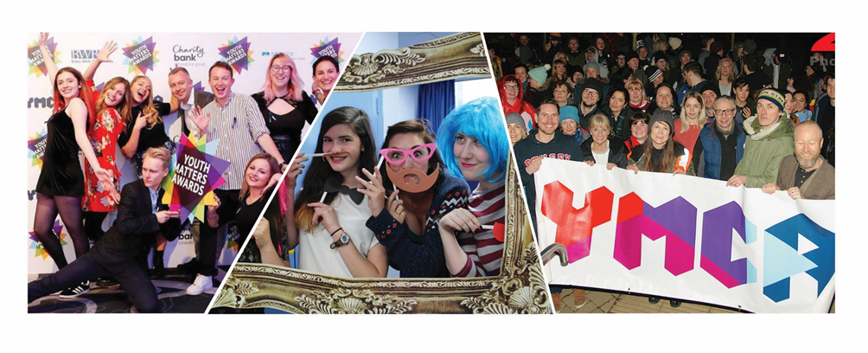

Welcome to Applicants from the CEO
Thank you for your interest in this role and I hope you find this pack and our website www.ymcadlg.org answer your questions. You probably will have heard of YMCA, the largest and oldest youth charity in the world, but you may not have heard about us. YMCA DownsLink Group is a grouping of local YMCAs across Sussex and Surrey, who over the past seven years have taken the decision to work more formally together to increase the capacity and impact of YMCA work in the region. Our last merger was in June 2018 when we welcomed Eastbourne & Wealden YMCA into the organisation. We took our name from a well-known bridle path that connects the South and North Downs called the Downs Link Way, following the merger of Sussex Central YMCA and Guildford YMCA in 2014. So, while we have a long heritage, we are a young and ambitious organisation. This creates opportunities that I hope you will relish.
We believe that the work of the YMCA is transformational, and our vision is built on transforming young lives. At YMCA DownsLink Group our work is targeted towards young lives on the fringes of our society with the aim of helping them to belong, contribute & thrive. Our services are focused on five key themes:
- Helping young people belong in the local communities they live in
- Supporting wellbeing in young lives
- Keeping children & young people safe
- Helping young people achieve
- Empowering young people to influence
Last year our services reached over 13,000 young lives across Sussex & Surrey. We are an ambitious organisation committed to further increasing our reach and the impact of our work.
I hope that you are sufficiently interested to read on and find out more about YMCA DownsLink Group and this role. I look forward to receiving your application and wish you well.
I welcome your interest.
Chas Walker
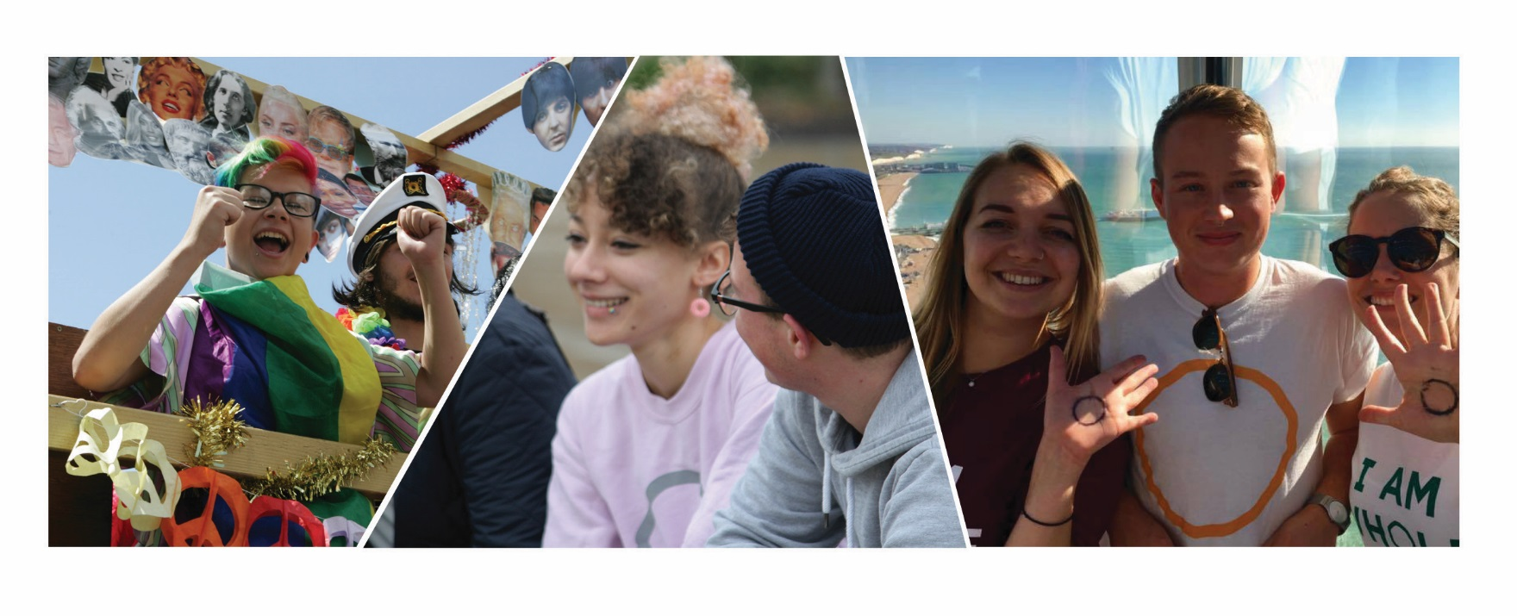
Chas Walker
CEO, YMCA DownsLink Group

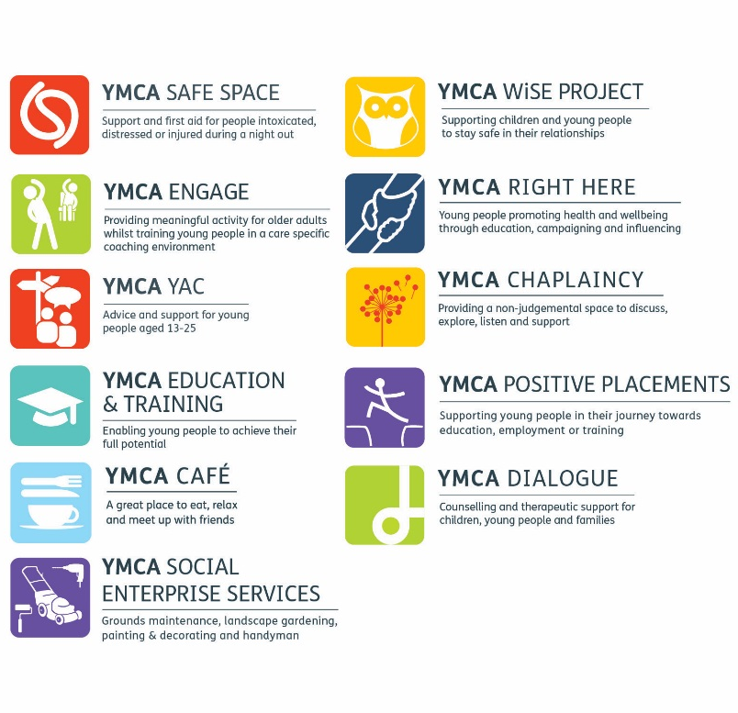
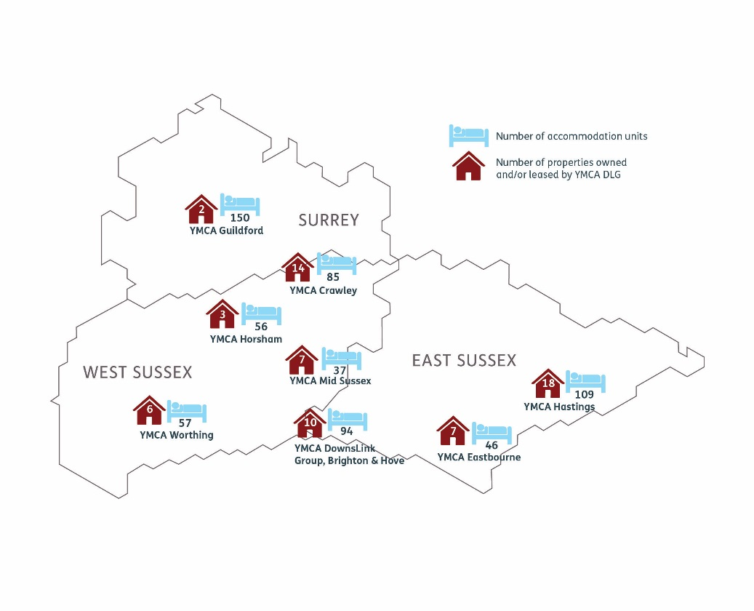
Our Localities

Our Projects

The YMCA Movement

YMCA
The YMCA is the largest and oldest youth charity in the world. It is a global, faith-based movement responding to the needs of young people around the world. From its humble beginnings in the City of London in 1844, the YMCA has grown to become a worldwide organisation reaching over 55 million members in 119 countries. As the founding ‘country’, YMCA England & Wales plays an important role in the worldwide movement and as a local YMCA we are committed to be an active member of the YMCA movement nationally and internationally. Find out more about the YMCA DownsLink Group at www.ymcadlg.org

YMCA England & Wales
The YMCA Movement in England and Wales is a federation of over 112 YMCAs that work across 740 recognised communities in England & Wales. Each YMCA is an independent, self-governing charity that affiliates to the YMCA Federation. YMCA England & Wales supports and facilities the work of the Federation providing the YMCA with a national voice in supporting the YMCA vision of transforming communities, so all young people can belong, contribute & thrive. It also supports YMCAs by promoting high standards of working, sharing best practice, fundraising on their behalf, partnering with them to pilot new projects, and providing training opportunities for their staff and volunteers.

Our Vision
Our vision is of an inclusive Christian movement transforming communities so that all young people can belong, contribute and thrive.
You will need to demonstrate a commitment to our aims and ethos, but do not have to be a practicing Christian to be part of our organisation. We value diversity in our staff team to reflect the people that we work with and our aim to be inclusive and celebrating diversity.
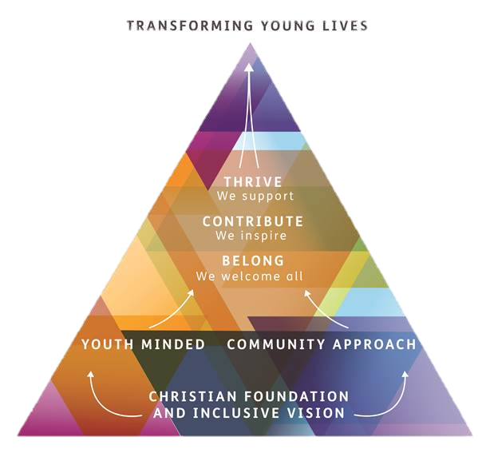

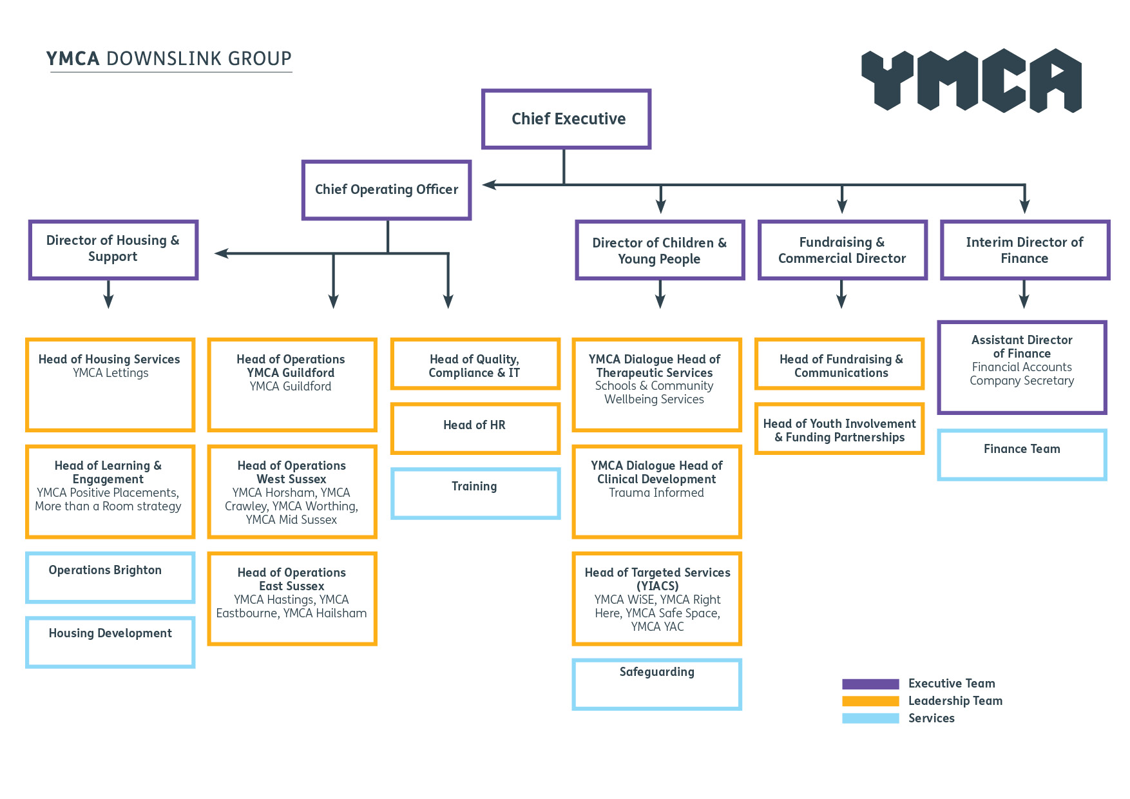
Our Structure

Policy on the Recruitment of Ex-Offenders
YMCA DownsLink Group actively promotes equality of opportunity for all, with the right mix of talent, skills and potential, and applications are welcome from a wide range of candidates.
We undertake not to discriminate unfairly against any applicant on the basis of a criminal record or other information revealed. Criminal records and other information will be taken into account for recruitment purposes only when they are relevant.
We select all candidates for interview based on their skills, qualifications and experience. We ask all applicants called for interview to provide details of their criminal record. Depending on the nature of the position applied for, YMCA DownsLink Group may request details of your entire criminal record or only of ‘unspent’ convictions as defined in the Rehabilitation of Offenders Act 1974.
We request that this information is sent under separate, confidential cover to a designated person within YMCA DownsLink Group and we guarantee that this information is only seen by those who need to see it as part of the recruitment process. We would point out that for the successful candidate, this information will be verified by requesting a Disclosure statement from the Disclosure and Barring Service before the appointment is confirmed.
Failure to reveal information that is relevant to the position sought could lead to withdrawal of an offer of employment or subsequent dismissal.
We ensure that all those in YMCA DownsLink Group who are involved in the recruitment process have been suitably trained to identify and assess the relevance and circumstances of offences. We also ensure that they have received appropriate guidance and training in the relevant legislation relating to the employment of ex-offenders e.g. the Rehabilitation of Offenders Act 1974.
At interview, or in separate discussion, we ensure that an open and measured discussion takes place on the subject of any offences or other matters that might be relevant to the position.
For those positions where a Disclosure is required, application forms and guidance notes will contain a statement that a Disclosure will be requested in the event of the candidate being made a conditional offer of employment.
We undertake to discuss any matter revealed in a Disclosure with the person seeking the position before withdrawing a conditional offer of employment.
Having a criminal record will not necessarily bar you from working with YMCA DownsLink Group. This will depend on the nature of the position and the circumstances and background of any offences. However, as the nature of the YMCA DownsLink Group’s work brings its employees & volunteers into contact with young people (those under 18 years old) and/or vulnerable adults, a criminal record or other information which makes an application unacceptable for a position of trust will render the applicant unsuitable.
As an organisation using the Disclosure and Barring Service (DBS) Disclosure service to assess applicants’ suitability for positions of trust, this policy complies with the DBS Code of Practice.

Declaration of Criminal Background & Guidelines for Working with Young People and/or Vulnerable Adults
The Rehabilitation of Offenders Act 1974 sets out to help people who have been convicted of a criminal offence and have not been convicted again in a specified period. This period is known as a rehabilitation period. Once a rehabilitation period has expired and no further offending has taken place, a conviction is considered to be ‘spent’. Once a conviction is spent, the convicted person does not have to reveal it or admit its existence in most circumstances.
The Rehabilitation of Offenders Act 1974 (Exceptions Order) gives some exemptions from the Act, whereby details of ‘spent’ convictions have to be declared. One of these exemptions is working with young people and/or vulnerable adults. When recruiting people to work in such positions of trust an employer is entitled to ask for details of all convictions, spent and unspent.
If you are invited to an interview, please bring with you a completed Declaration of Criminal Background Form which is enclosed in this application pack. It asks for details of spent and unspent convictions, cautions, reprimands and final warnings. You should complete the form and place it in an envelope marked ‘Private and Confidential’, addressed to the Interview Panel. Your name should be clearly stated on the front.
The information relating to criminal convictions will only be seen by the interview panel if we are considering offering you employment. If you wish to discuss the information that you have given, please mention this to an interviewer. Having made its selection, the panel may wish to discuss any information given with you. Having a conviction will not necessarily bar you from consideration for the post. Criminal records will be taken into account only when they are relevant to the position for which you are applying. The information you provide will remain confidential.
If you are made a conditional offer YMCA DownsLink Group will apply for an Enhanced DBS Disclosure depending on the nature of the job.
The DBS offers organisations a means to check the background of job applicants to ensure that they do not have a history that would make them unsuitable for the post. DBS Disclosures are provided by the Disclosure and Barring Service, an executive agency of the Home Office. Enhanced disclosures provide details of a person’s criminal record including convictions, cautions, reprimands and warnings; they also contain details from lists held by Government departments of those considered unsuitable for this type of work. Organisations using the DBS process must comply with the Code of Practice, a copy of which is available on request.
If you have any queries, please speak to a member of the HR team.

