An open letter to MP Henry Smith,
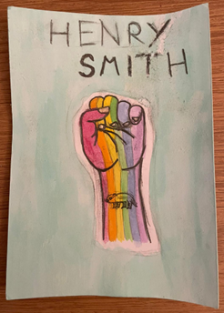
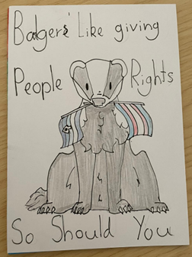
We are writing to you on behalf of the young people who engage with our LGBTQU+ Haven at the YMCA Youth Advice Centre in Crawley. (LGBTQU+ stands for: Lesbian, Gay, Bisexual, Trans, Queer, Unsure, plus any other LBGT+ identity).
Over the past 18 months, we have had more than 60 local young people engage in the project and we have successfully supported the county wide effort towards suicide prevention for this vulnerable group of young people.

At the start of June, we were asked to get our young people to write postcards to the Prime Minister and their local MP by Katie Vincent, the CEO of Allsorts Youth Project (the commissioned LGBT+ service for Sussex).
We asked the young people to use their own words to talk about the action they wanted to see the government take to protect the human rights of LGBTQ+ people, but especially trans people following a horrendous few weeks of anti-trans news in the lead up to June 2022 (Pride Month). The young people chose to write directly to you as their local MP, asking for you to use your power to support Crawley’s LGBTQU+ youth. The young people were upset that when looking at your voting record on ‘TheyWorkForYou’ that you appeared to always vote in favor of animal rights but generally against granting LGBT+ rights.

We would love to invite you to come and meet the young people and parent / guardians of the young people engaged with our LGBTQU+ Haven, so that they can speak to you directly about how you can represent them as their local MP on these issues and explain what a significant impact the project has had on their mental health and wellbeing. The impact of the project has recently been recognised by the BBC, where we were shortlisted for the BBC Sussex & Surrey Make A Difference Awards in the Community Group category.

Having previously worked with you through my work with National Citizen Service whilst working at Crawley Town Community Foundation, I know how proactive you have been in the past at engaging with local young people on the issues that matter to them – I hope that you are able to afford the same opportunity to this group of vulnerable young people and their parents / guardians.

Overleaf are some of the postcards and messages that the young people wrote for you.

Best wishes,
Elinor Adie (she / her)
West Sussex Youth Hub Development Manager
LGBTQU+ Champion

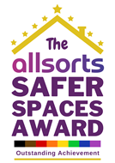

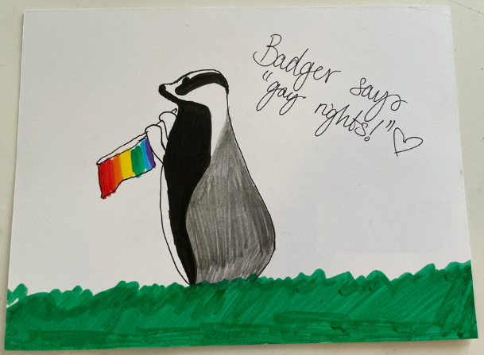
“Henry Smith – if you care about badgers, you can care about your fellow humans too. Even the ones who aren’t like you. Do better”
LGBTQU+ Haven Service User (25)

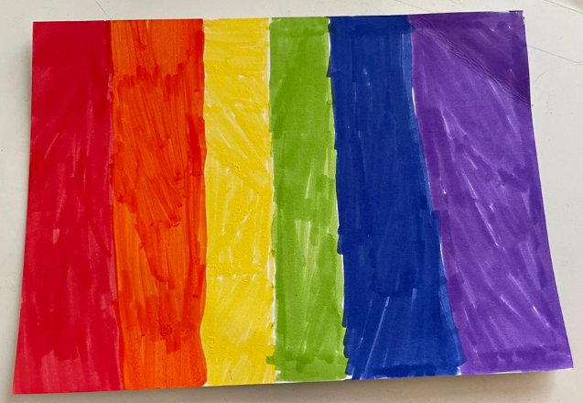
“LGBTQIA+ Lives Matter.
Normalise Trans Rights.
Normalise Gay Rights.
Normalise Lesbian Rights.
Normalise Bisexual Rights.
Normalise LGBTQIA+ Rights”
LGBTQU+ Haven Service User (14)

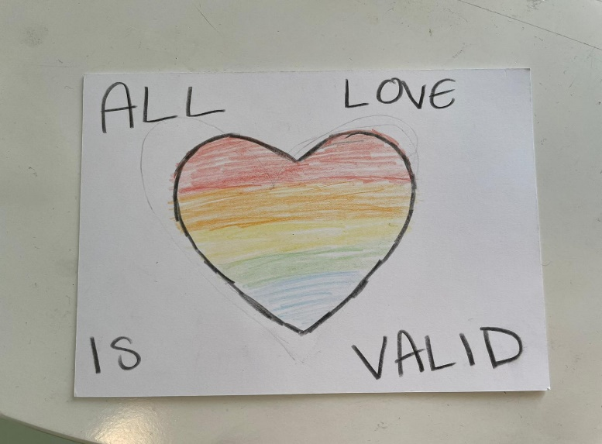
“Dear Mr Henry Smith,
As Crawley’s MP you need to show your support with our young LGBT+ children because homosexuality is being accepted and being some to represent our borough, we need your help in knowing it is okay!”
LGBTQU+ Haven Service User (12)

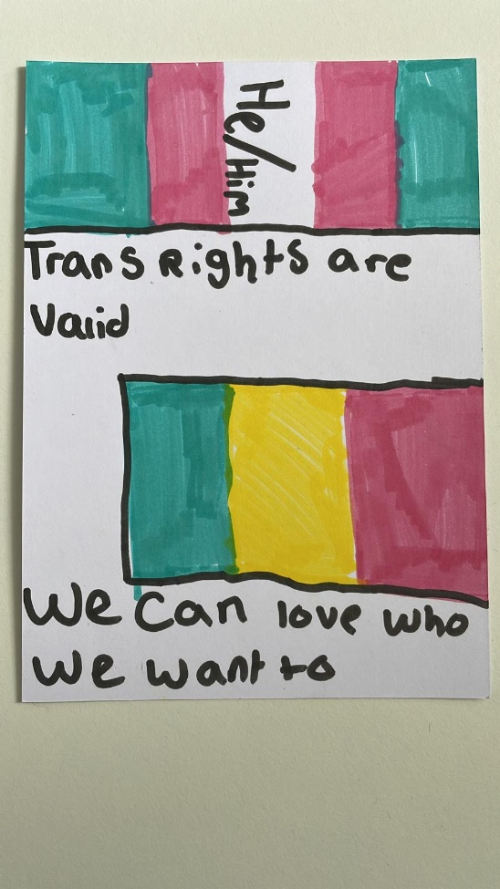
“This is not okay. Support LGBTQ+ rights”
LGBTQU+ Haven Service User (12)

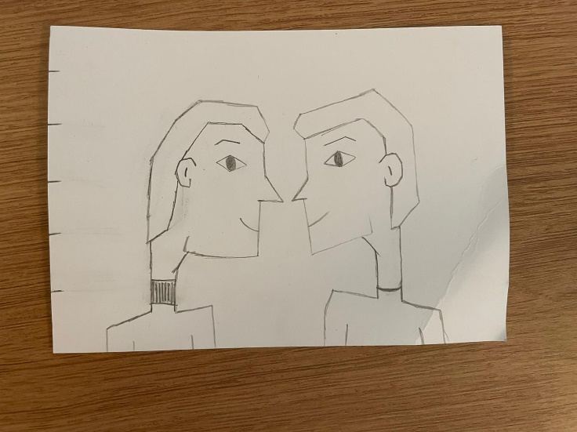
“Do better, make us feel valid”
LGBTQU+ Haven Service User (22)

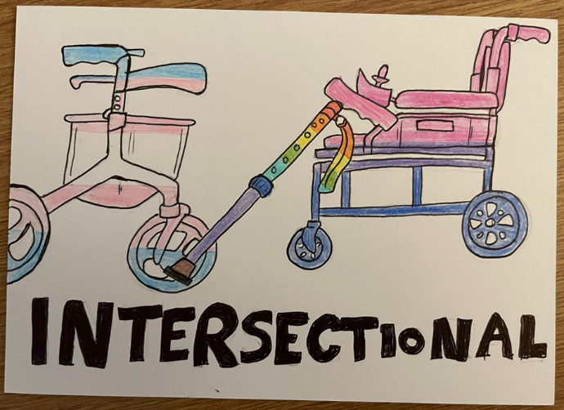
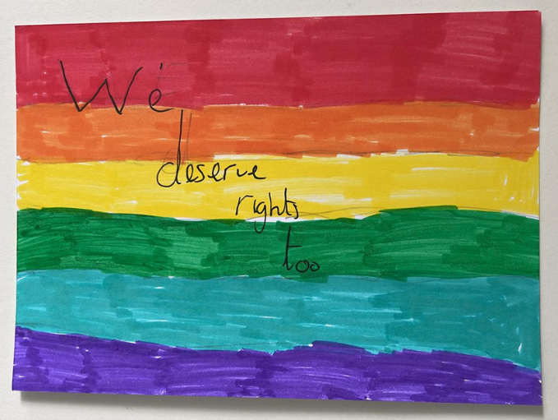
“Every minute conversion therapy is legal, someone dies. Please don’t let Crawley’s LGBT+ children die”.
LGBTQU+ Haven Service User (15)

“Hi. I am a trans young person and I feel you are not doing enough to make me feel valid. I dislike your behavior and I would like you to change this. How I feel is not good and you’re making me feel bad”
LGBTQU+ Haven Service User (13)

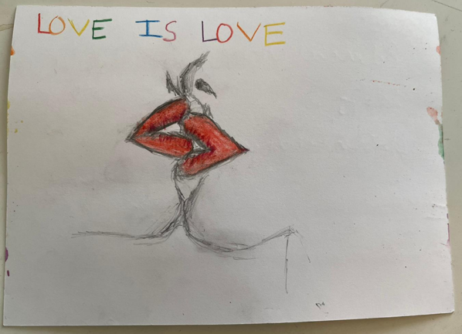
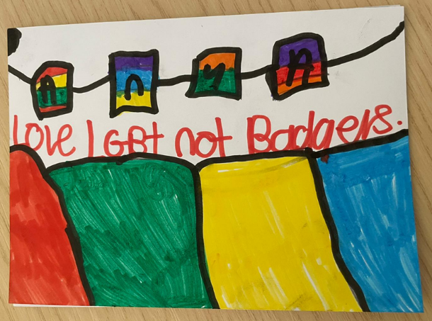
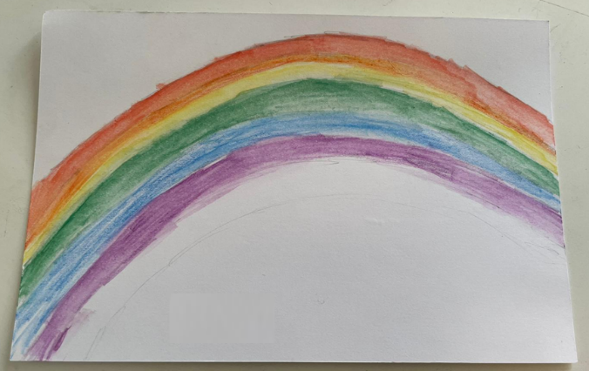
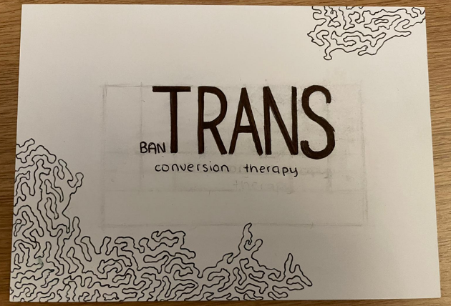
“Education deters discrimination.
Save the new generation. Your future.
Teach equality and acceptance”.
LGBTQU+ Haven Service User (14)
“Please make gender identity clinics more accessible. We would all appreciate if you could try and vote for conversion therapy being banned. Thank you and goodnight”
LGBTQU+ Haven Service User (13)

“Gender clinics currently have a waiting time of 14 years which is insane as over 80% of trans people have thought about suicide while over 60% have tried. A shorter time would save thousands of lives”
LGBTQU+ Haven Service User (14)
“Hi, I’m a queer teenager and I’m writing to discuss your general view on LGBT+ individuals and the general anti-ness of it. Do not dismiss this message. Your party are killing us, we need your intervention. Please help us. Ban Trans Conversation Therapy”.
LGBTQU+ Haven Service User (14)

