Young Person Self-Referral form

Please fill out this form to request help and support from WiSE. Try to give us as much information as possible. You might want to fill this out with the help of a trusted adult, such as a parent/carer, social worker or youth worker. Scroll to the bottom to find a list of other services that can help.
If you are in immediate danger, you must call the Police on 999 immediately.
Please email your completed form to:

Surrey: wise.surrey@ymcadlg.org
Brighton & Hove and East Sussex: wise@ymcadlg.org

We will contact you within 10 working days once we have received it.
Name
Date of Birth
Address

Gender and pronouns
Ethnicity
How can we contact you?
Phone / Email
School/college:
(we won’t contact your school without your consent)
Name and phone number of a safe, trusted adult we can contact in an emergency (eg. Mum, dad, grandmother, youth worker)
Do you have any professionals in your life? (ie. social worker / counsellor) Please give us their name and contact details
How can we help you?
 | Relationships & grooming (tick the ones which apply to you) |  |  | Safety (tick the ones which apply to you)
☐ | I think I might have been in a toxic or abusive relationship |  | ☐ | I need help with online safety
☐ | I think I might have been groomed |  | ☐ | I need help managing my sexual health or going to a sexual health clinic
☐ | I want to learn more about grooming and how it can happen |  | ☐ | I am worried because I have sent a nude photo to someone online
☐ | I need some help understanding what a healthy relationship/friendship looks like |  | ☐ | I’m worried the person I’m talking to online is not who they say they are
☐ | I want to learn about setting healthy boundaries |  | ☐ | Someone I’m talking to online is pressuring me to send pictures of myself to them
☐ | I think some of the people I hang out with are controlling and/or make me do things I don’t want to do |  | ☐ | Someone I speak to online wants me to meet them and I’m worried about it
☐ | I want to know more about consent |  | ☐ | I think I might have been sexually abused or assaulted
☐ | I feel pressured into having sex or doing something sexual |  | ☐ | I want to talk to someone about when I ran away from home
☐ | I’m worried I could be pregnant |  | ☐ | I often run away from home and want to talk to someone about it
☐ | My friend/partner pressures me into drinking alcohol and/or taking drugs |  | ☐ | Someone in my life is making me feel unsafe

Anything else? Please write anything else you would like help with that has not been covered by the tick boxes or give more information about the ones you have ticked.

If you need help now, here are some places you can contact:
You can scan the QR codes or click the links.
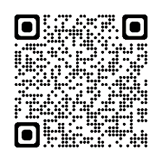 | 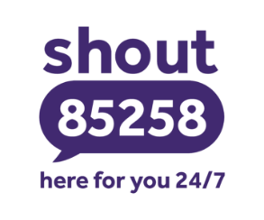 | https://giveusashout.org/
 | 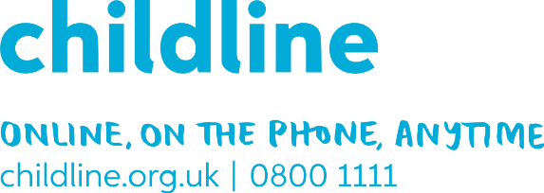 | https://www.childline.org.uk/
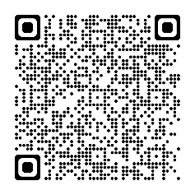 |  | https://www.themix.org.uk/
 |  | https://www.nspcc.org.uk/keeping-children-safe/online-safety/
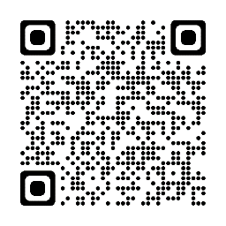 |  | https://www.ceop.police.uk/Safety-Centre/
 | 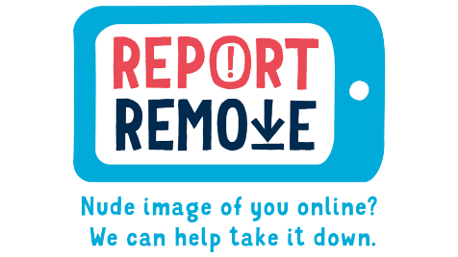 | https://www.childline.org.uk/info-advice/bullying-abuse-safety/online-mobile-safety/report-remove/  Here to help young people to report sexual images and videos of themselves and remove them from the internet.

